# Lab 01 - Manage Microsoft Entra ID Identities

Made by Valeriy Manuilyk <3

## Task 1: Create and configure user accounts

1. Sign in to the ****Azure portal**** - https://portal.azure.com.

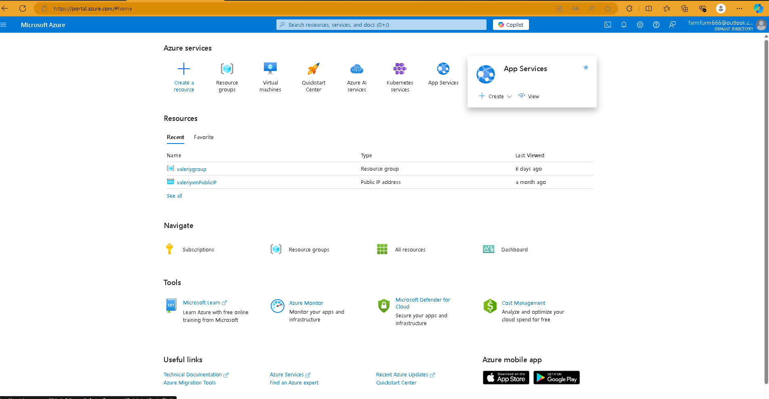

1. To proceed to the portal, select ****Cancel**** on the ****Welcome to Azure**** splash screen.

**Done ✅**

1. Search for and select Microsoft Entra ID. Microsoft Entra ID is Azure’s cloud-based identity and access management solution. Take a few minutes to familiarize yourself with some of the features listed in the left pane.

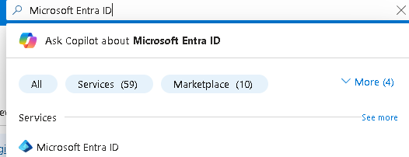

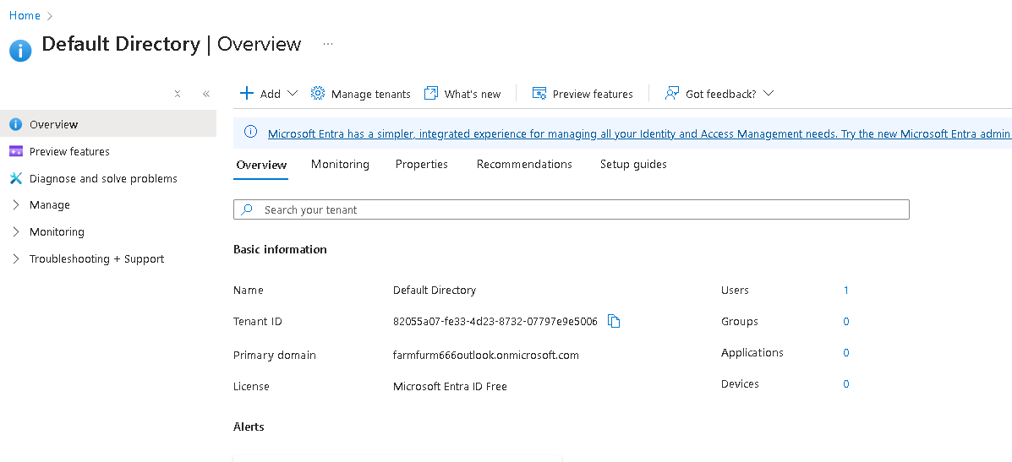

4.Select the ****Overview**** blade and then the ****Manage tenants**** tab.

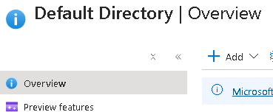



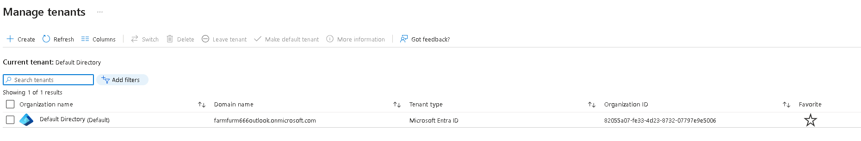

5. Return to the ****Entra ID**** page by pressing back in the browser or selecting the option in the breadcrumb menu.

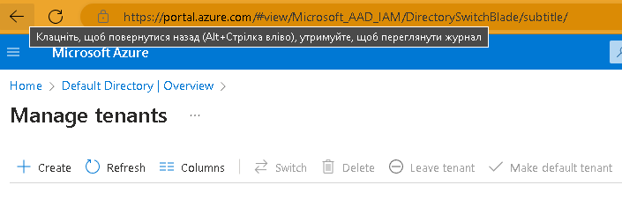

1. Select ****Licenses****. From here you can purchase a license, manage the licenses you have, and assign licenses to users and groups. Select ****Licensed features**** to see what is available.

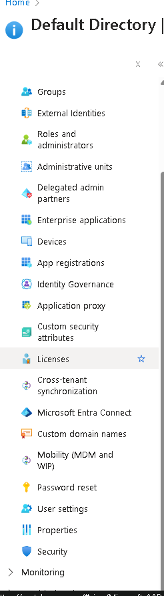

1. Select ****Users****, then in the ****New user**** drop-down select ****Create new user****

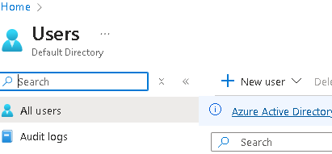.

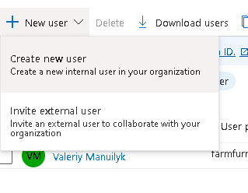

8.Create a new user with the following settings (leave others with their defaults). On the ****Properties**** tab notice all the different types of information that can be included in the user account.

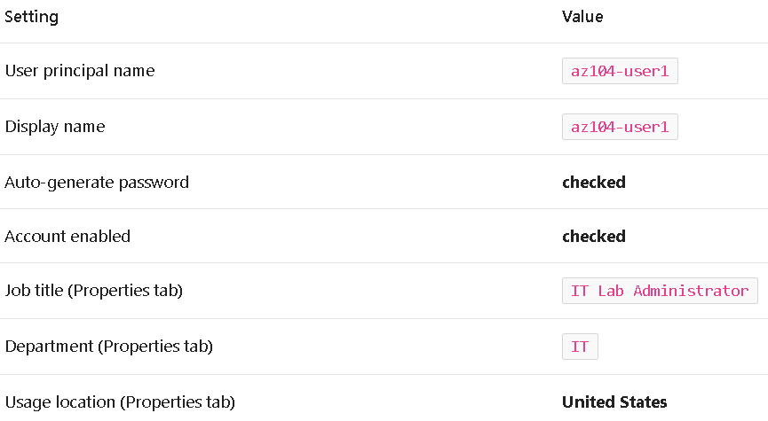

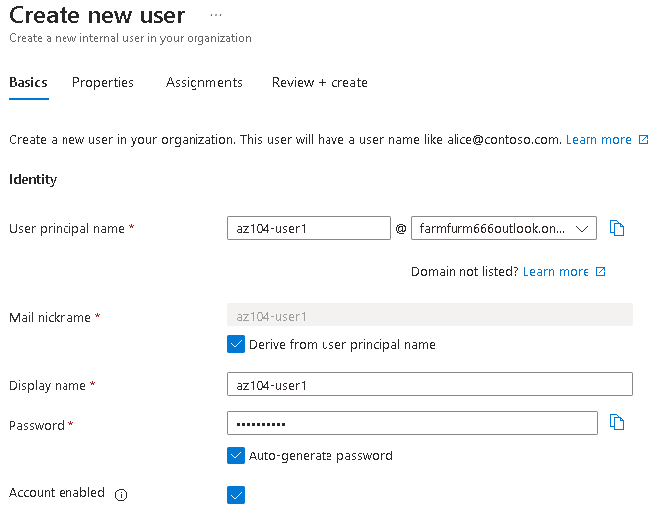

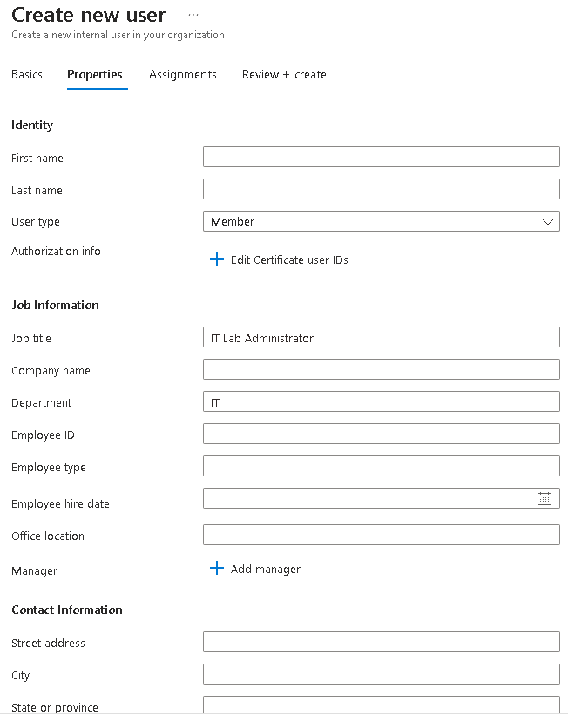

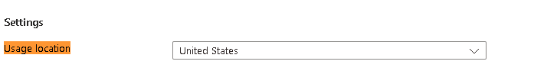

9. Once you have finished reviewing, select ****Review + create**** and then ****Create****.

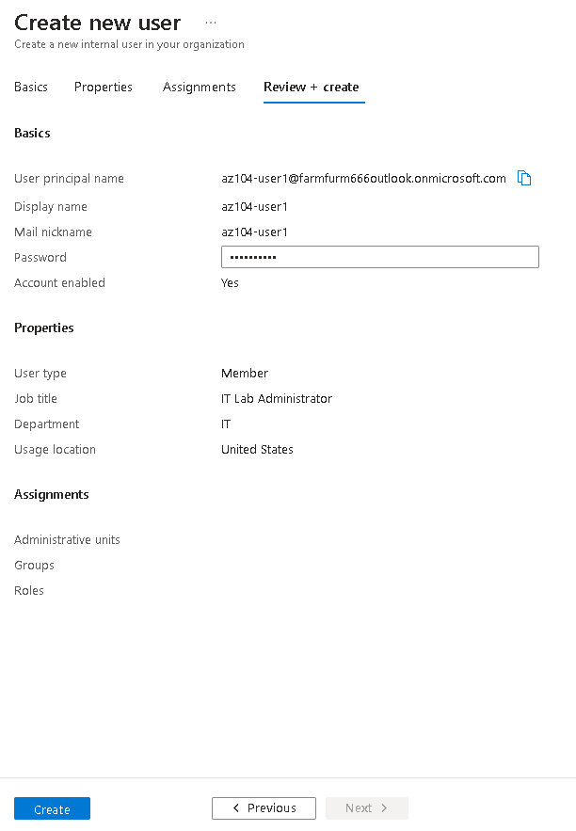



1. Refresh the page and confirm your new user was created.



11.In the ****New user**** drop-down select ****Invite an external user****.

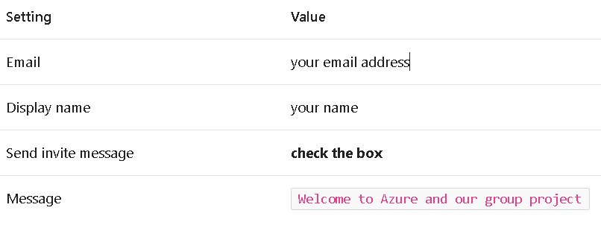

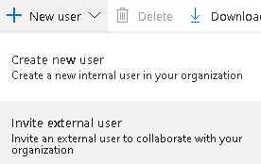

12.Move to the ****Properties**** tab. Complete the basic information, including these fields.

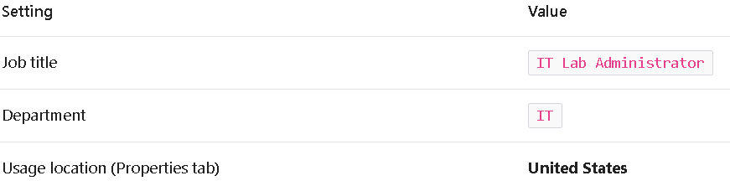

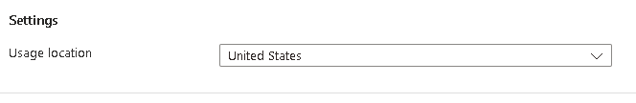

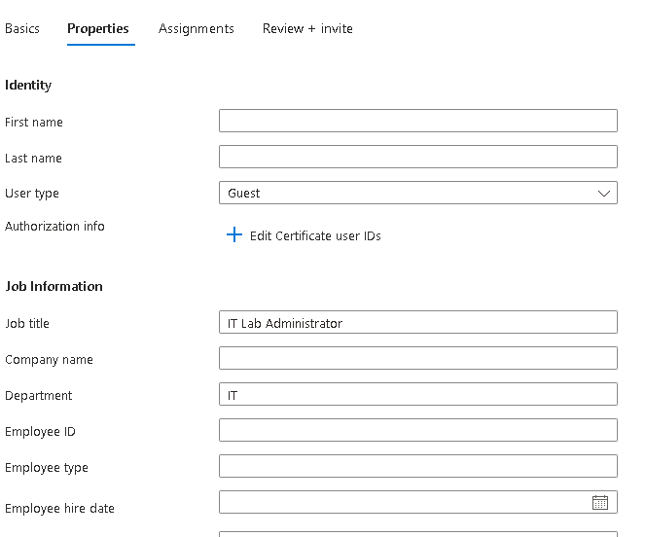

1. Select ****Review + invite****, and then ****Invite****.



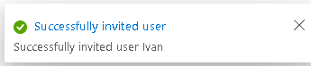

1. ****Refresh**** the page and confirm the invited user was created. You should receive the invitation email shortly



## Task 2: Create groups and add members

1. In the Azure portal, search for and select Microsoft Entra ID. In the ****Manage**** blade, select ****Groups****.

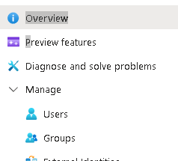

2.Take a minute to familiarize yourself with the group settings in the left pane.

* ****Expiration**** lets you configure a group lifetime in days. After that time the group must be renewed by the owner.
* ****Naming policy**** lets you configure blocked words and add a prefix or suffix to group names.

3.In the ****All groups**** blade, select ****+ New group**** and create a new group.

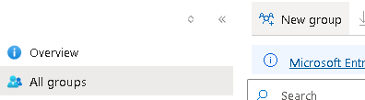

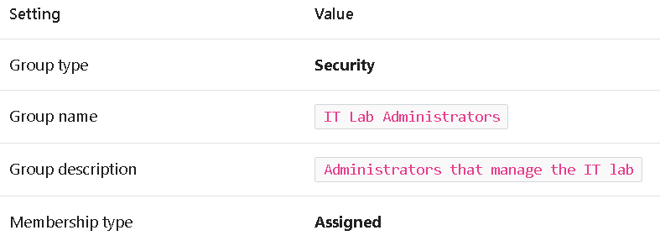

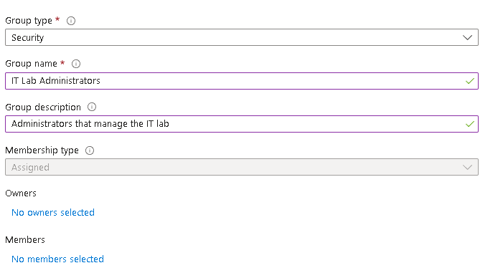

4.Select ****No owners selected****.



5.In the ****Add owners**** page, search for and ****select**** yourself (shown in the top right corner) as the owner. Notice you can have more than one owner.

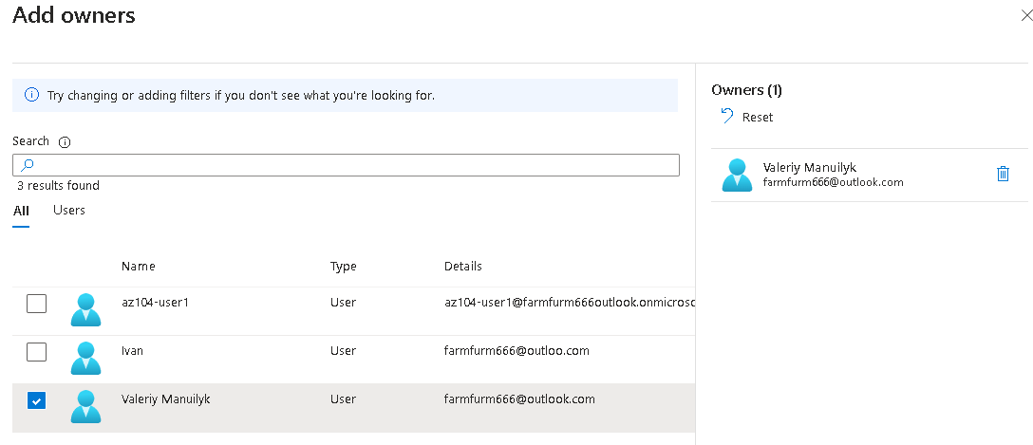

6.Select ****No members selected****.

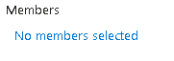

7.In the ****Add members**** pane, search for and ****select**** the ****az104-user1**** and the ****guest user**** you invited. Add both of the users to the group.

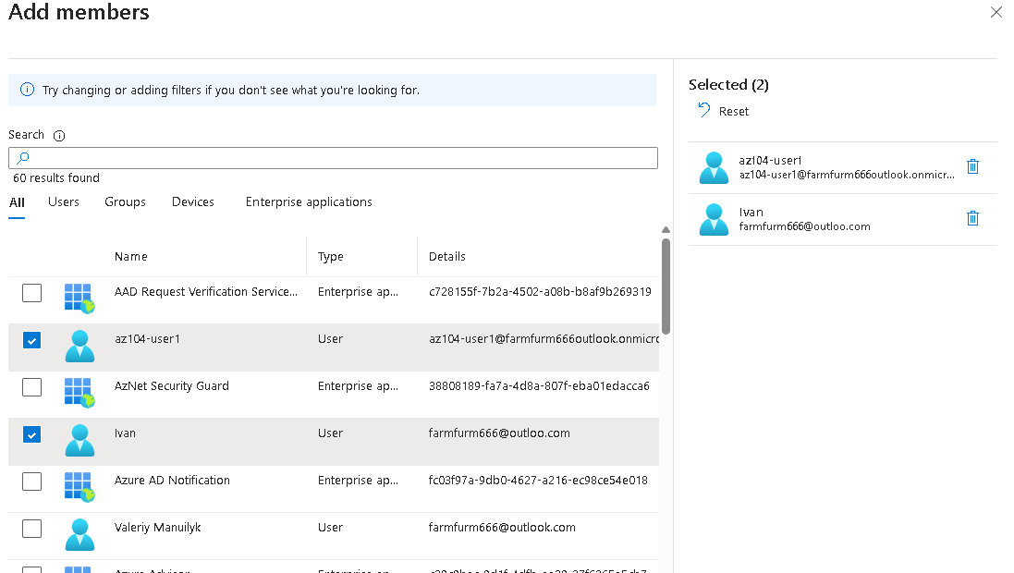

8.Select ****Create**** to deploy the group.

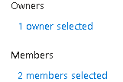

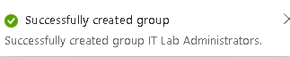

9.****Refresh**** the page and ensure your group was created.

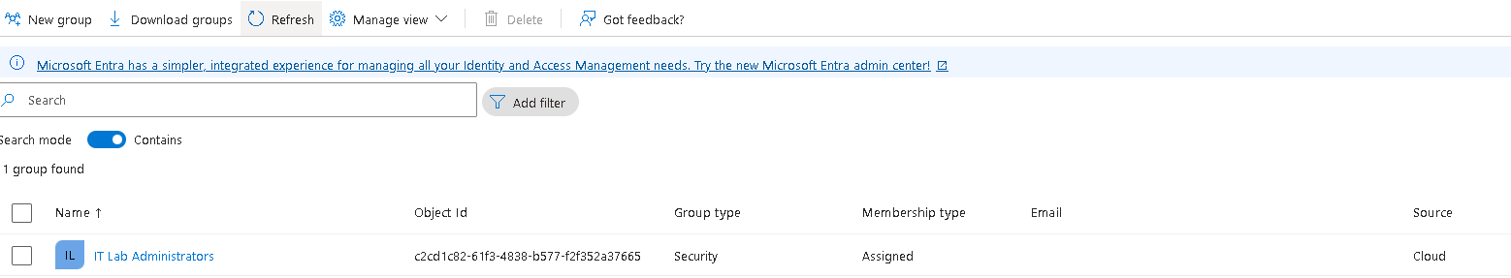

10.Select the new group and review the ****Members**** and ****Owners**** information.

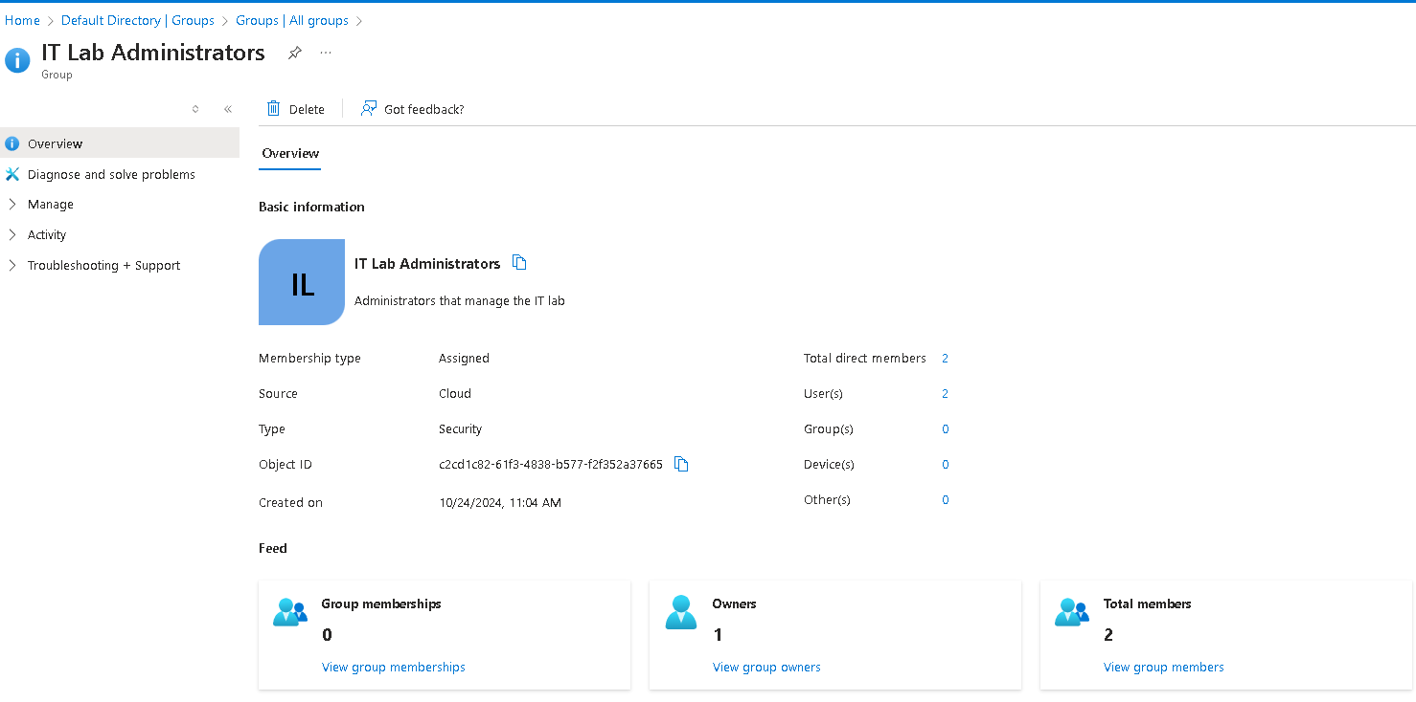

**Conclusion:**

A tenant represents your organization and helps you to manage a specific instance of Microsoft cloud services for your internal and external users.

Microsoft Entra ID has user and guest accounts. Each account has a level of access specific to the scope of work expected to be done.

Groups combine together related users or devices. There are two types of groups including Security and Microsoft 365.

Group membership can be statically or dynamically assigned.